Slurm select/cons_res Plugin specification

Job_test.c/_select_nodes() function to handle both core and node level details to give number of cpus allocated for every nodes. Some nodes can be allocated zero cpus.
- Core level allocation is handled in _get_res_usage function especially _allocate_cores wrapper function calling _allocate_sc
- Node level allocation is handled in _choose_nodes and _eval_nodes function.
In the below figure-1 we can get overall view of the interaction and side notes gives more details about the function and interaction. Algorithm for important functions will be explained further.
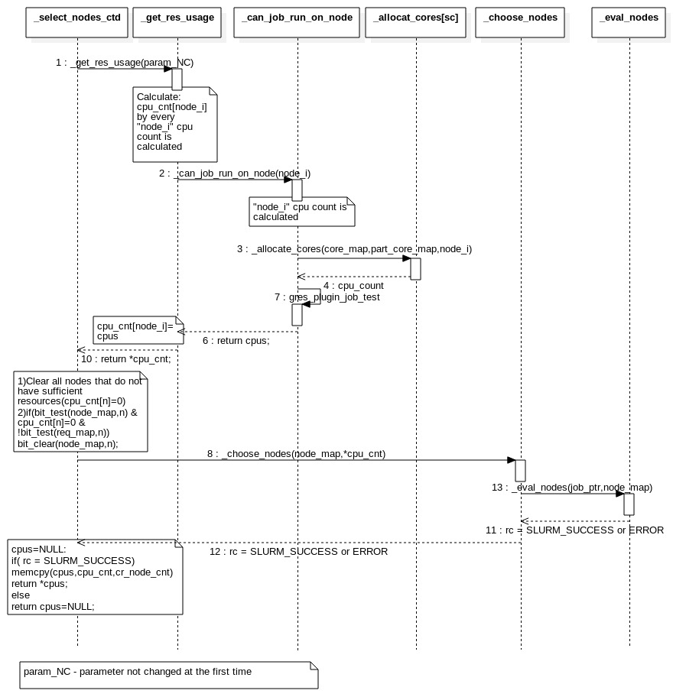
Figure-1-selectnodes function interaction details

Before entering the select_nodes it has to pass from node_select.c common function named _select_g_job_test() to gather available nodes bitmap and jobs details to select specific plugin for selection process as configured in slurm.conf file. In the fig-2 we can see the connection between _select_g_job_test() to _select_nodes() function and high level node manipulation also.

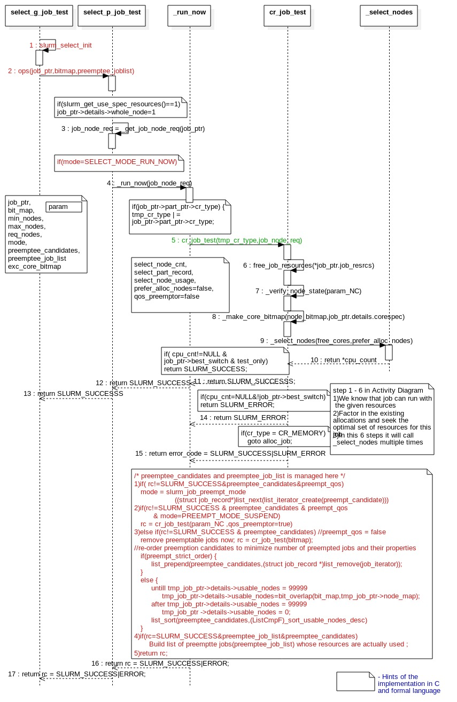
Figure-2- Entry from the select plugin to select_nodes function to handle insufficient resources
in consumable manner from preempt_candidates job_list resources.
_select_nodes function will get selected node_map and core_map and to allocate specific nodes and cores(CPUs) to the job. Core level allocation for every single node is handled in allocate_core. More details about the allocate_core function is given in fig-3 below.
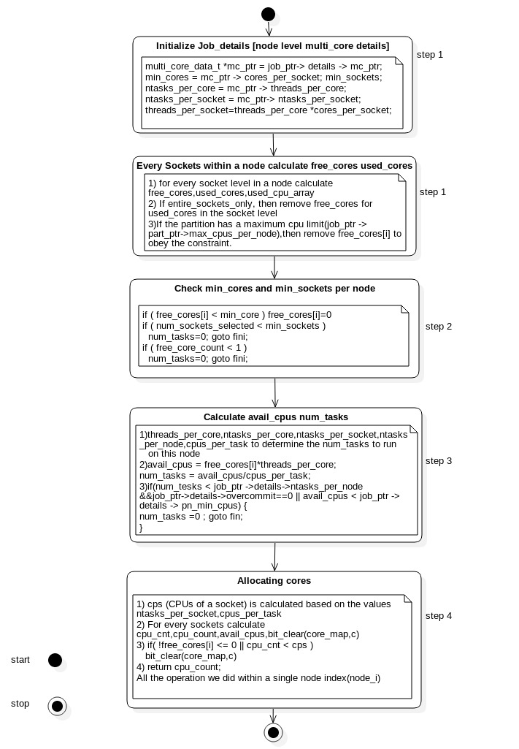
Figure-3-_allocate_sc is the wrapper function of _allocate_core. It will bit_clear cores does not match to the jobs specification and return the matched cores count for the node index(node_i).
_eval_nodes function check the nodes that matched for the jobs_specification and pick the best nodes out of the list. _eval_nodes function was based on the different criteria network topology, least loaded node, consecutive nodes and busy nodes only to pick the best nodes. Some of the eval_nodes criteria will be ignored by the jobs details. _eval_nodes_busy function select the busy nodes more preference than idle nodes from the matched nodes from the _chooed_nodes() function. _eval_nodes_busy function algorithm is shown below Fig-4.
